St Matthias’ Church - Hatch Street
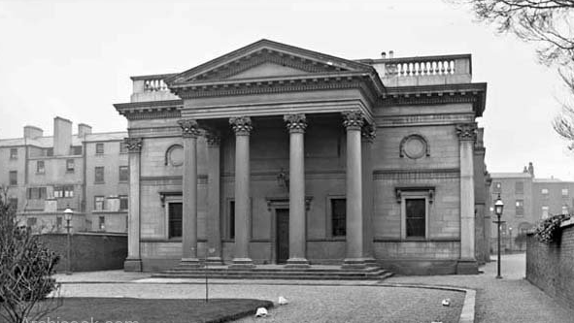
Built in 1842, it was to be part of a development called Wellington Square which never went ahead. The architect was Daniel Robertson, who was better known for designing houses such as Lisnavagh in Co Carlow (home to Bunbury boards) and the Bunbury family came to the aid of the widow Robertson when her husband died leaving just over 20 pounds. The land around it was sold to the railway company for the Harcourt Street terminus. The last service was held on Sunday the 25th of March 1956. There had been a threatened occupation by some of the parishioner to try and save the church but it was demolished by the end of the 50’s.
St Matthias’ was an evangelical church and it was reported by the newspapers to have been full on a Sunday at the height of its popularity. In 1869 The Church closed temporarily to extend the nave and add a chancel. This allowed for an additional five hundred seats to be installed. During this time services were moved to the National Exhibition Hall (now the National concert Hall) on nearby Earlsfort Terrace. Achilles Daunt was the preacher at the time and according to the Oxford Dictionary of National Biography, “Daunt had to use the large concert hall of the exhibition palace. His sermons were so popular that his congregations averaged 3000 or more people.”
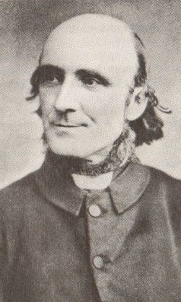
By the 1950s the congregation was very sparse and a decision was taken by the Church of Ireland that the church was no longer viable. The site of the church is now office buildings.
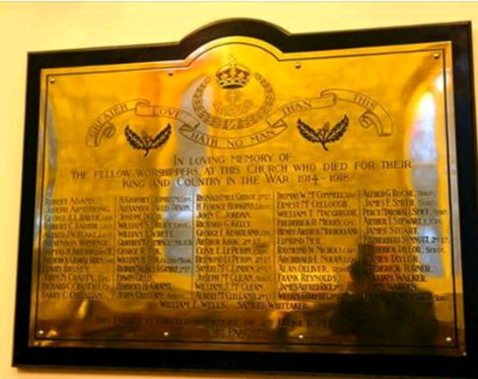
The war memorial from St Matthias’ Church, which was on Adelaide Road/Hatch street was restored and relocated to St Audoen’s Church, Cornmarket on 8th November 2015. It is believed that the east window was moved to St Michan's.
www.irishgenealogy.ie have 1203 baptisms and 183 marriages online and digitised
The RCB Library holds the following parish registers:-
Baptisms 1867-1955
Marriages 1873-1955
November 2015.

