The Dunlop Rubber Company and its Irish roots 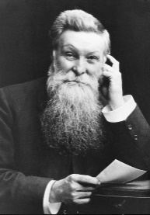
John Boyd Dunlop was born on February 5th 1840 on a farm in Dreghorn, Ayrshire in Scotland. He studied veterinary medicine in Edinburgh Veterinary College and on graduating moved to Downpatrick in Ireland. There he met and married Margaret Stevenson in 1871.
In 1880 he set up, with his brother James, a practice in Belfast that subsequently became one of the largest Veterinary practices in Ireland.
In the late 1880s he was playing with his son John and as an experiment he fitted an inflated rubber tube to a wooden disk wheel about 96 centimetres in diameter. He then got an iron wheel with the same measurements and rolled both. The Iron wheel stopped but the one with the pneumatic tube kept going, hit a wall and rebounded. He then attached the tubes to the rear wheels of his son’s tricycle and it ran a lot better than with solid wheels. Soon after that he designed inflatable tyres for a full sized bicycle and tested them with “even more startling results”. He continued to develop and test them in Cherryvale Sports Club in Belfast and applied for and was granted a patent on Dec 7th 1888.
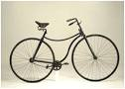 In March 1889 Willie Hume, the Captain of Belfast Cruisers Cycling Club was the first member of the public to buy a ‘JK Starley’s safety bicycle’ equipped with the latest newly patented Dunlop designed pneumatic tyres. Two months later Hume won all four cycle races at the Queen’s College Sports. In Liverpool the following month he won three out of four races.
It was at the Queen’s College Sports that Dunlop first met Harvey Du Cros from Dublin, President of the Irish Cycling Association, a former Irish Boxing and Fencing Champion, a Paper Manufacturer and general Entrepreneur. Du Cros was to play a major role in the development of the Dunlop Tyre. This plaque at 67 upper Stevens St Dublin 2 reads
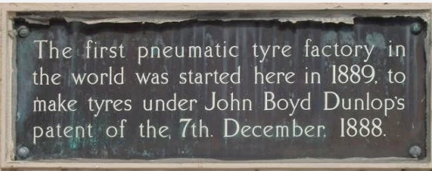
“The first pneumatic tyre factory in the world was started here in 1889 to make tyres under the John Boyd Dunlop’s patent of December 7th 1888”.
In 1892 Dunlop sold his Veterinary practice in Belfast and with his family moved to Dublin and for some time lived on Mount Merrion Avenue, near the Grove Avenue junction). Before 1901 he moved residence to Simmonscourt Road in Ballsbridge where he died in 1921 and was buried in Dean’s Grange Cemetery.
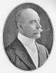 With Harvey Du Cros, whose ancestors were Huguenots and a Past Pupil of The Kings Hospital School in Dublin, he set up the Pneumatic Company and Booth’s Cycle Agency. At that time he sold the patents for the pneumatic Tyres to Du Cros for £3000. Shortly after that they were informed that the Patent was invalid as another Scot Robert William Anderson had registered a patent for a pneumatic tyre 50 years previously, the man was long dead but the patent was still there.
Regardless, the company continued to prosper and in 1895 John Boyd Dunlop retired from the business retaining a small shareholding. In 1896 Du Cros ever the entrepreneur sold the company to a British Financier (Vulture Fund) called Ernest T Hooley for £3 million and was rebranded as the DUNLOP PNEUMATIC TYRE CO. Hooley in turn brought it public a few years later and sold it for £5m. The company produced its first automobile tyre in 1900. Du Cros remained as MD and later Chairman of the Dunlop Rubber Company under its many reincarnations until he died in December 1918. During his sojourn in the UK he had time to become a Conservative Party MP for the constituency of Hastings in 1906. He resigned that seat two years later to be succeeded by his son Arthur.
Du Cros was born in Rathgar on June 19 1846 and educated at The King’s Hospital school, in 1866 he married Annie Jane Roy in Dublin and they were blessed with 6 sons, all of whom it seems took after their father at least they inherited his entrepreneurial spirit.
- Frederick was a twin born in 1868 and was killed in WW1 in France in 1917.

- Alfred the other Twin emigrated to London where he became involved with the Conservative Party like his Dad and in 1910 was elected Conservative MP for Bow and Bromley.

- 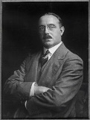 Harvey Junior was born in Dublin in 1872. When he was just 20 His Dad sent him to America to set up a pneumatic tyre company. Whilst there he formed a lasting relationship with the Goodyear Tyre Co. We don’t know if he sold his own branch of the company to Goodyear. But shortly afterwards he left the Dunlop Rubber Company and founded the SWIFT Automobile Co and was involved with the YELLOW CAB Co which had been set up by John D Hertz. Hertz sold the Cab Company in the 1920s and set up an auto rental company which still bears his name. On his return to England Harvey secured the Agency to import Mercedes Cars into UK. He was a major investor in the AUSTIN motor company and was Deputy Chairman of Austin until his death in 1928.

- William (1874—1937) and George (1875—1946) In the early 1900s Harvey Snr set up W & G Du Cross to import automobiles into Ireland. Both sons were employed by the Dunlop rubber company but encouraged by their father they looked for other investment opportunities. They procured the Agency to sell French built PANHARD and LEVASSOR autos in the UK, Ireland and the Colonies. They even had their motor Showrooms on the ground floor of Dunlop Rubber HQ in London. They also had the Mercedes, Austin, Swift and Panhard and Levassor franchises for Ireland.
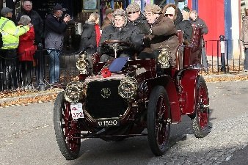Their next venture was setting up one of the largest Taxi fleets in London using NAPIER and PANHARD and LEVASSOR bodies with the W & G badges and yellow bonnets. In 1910 they employed more than 1000 drivers. From that they branched into building delivery vans and small trucks. In 1913 they had 600 cabs but the advent of the Underground, Trams, Rail and Bus routes ate into their business so they converted many cabs into Delivery vans. Later in 1923 they branched into buses and assembling American Yellow Cabs. Of course the Chicago based Yellow CabCompany was closely connected to the Mob wars in Chicago. 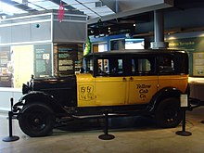
They finally went out of business in 1935 when their plant was taken over by the Rootes Group builders of Humber and Hillman cars.
- 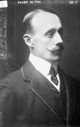Arthur (26/01/1871—28/10/1955)
Like his Father and siblings he remained on the payroll of Dunlop Rubber Company. In 1892 he was appointed General Manager of Pneumatic Tyres and Booths Cycle Agency and in 1897 he was promoted to Joint Managing Director with his Father. By 1914 the Company employed 4000 in Castle Bromwich and in 1927 they had 12000 on the payroll. By then Arthur was both MD and CEO and at least three other members of the family were on the Board of the Company or in Senior Management positions. He was combining his own personal projects and investments with those of the Dunlop Rubber Company and was in reality dipping into the company funds. The problems were exacerbated when the company almost went into liquidation in 1921. Arthur, Alfred and George were finally sacked.
In the meantime Arthur was created a Baronet in 1916 by King George V as a reward for purchasing a bundle of love letters that had been written by Edward V11 to Daisy Warwick, she had threatened to sell them to the press and embarrass the Royal Family.
He was also twice an MP in Hastings and then Clapham till 1922. His former home in Hastings was burned to the ground by suffragettes angry at his opposition to votes for women. Arthur died in 1955.
And so ended the original Irish connection with the Dunlop Rubber Company although Dunlop did maintain a production plant in Cork until 1984.
© Des Smyth – February 2018

