Sources –Huguenot Cemetery , Merrion Row
We would like to thank Carmel Drummond of The Dublin Parks Department, Dublin City Council for her help in getting access to the cemetery.

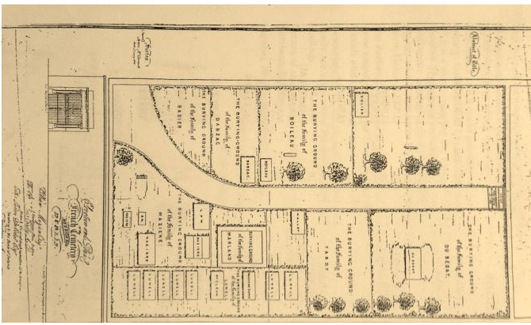
1 1860 Map courtesy of the Huguenot Society of London.
2 Registers of the French Non-Conformist churches of Lucy Lane and Peter Street, Dublin
(Register of Deaths: 1702-1731 & Register of Burials: 1771-1831)
Published by the Huguenot Society of Great Britain and Ireland in 1901, this volume, edited by Thomas Philip Le Fanu. Publications of the Huguenot Society of London ; vol. XIV Aberdeen : [University Press Limited] (1901)
3 Journal of the Association of the Memorials of the dead in Ireland. No IX, vol viii page 535-538
For further information Dr Michael JS Egan and Danny Parker have both published work on this cemetery.

